**VAISHNAVI E 231901059**

**EX.NO:3B DATE: SHELL SCRIPT**

**AIM:** To write a Shell script to generate a Fibonacci series using for loop.

**PROGRAM:**

echo "Enter number of terms:"

read n a=0 b=1

echo "Fibonacci series: " echo -n "$a $b" for i in $(seq 3 $n); do c=$((a + b)) echo -n " $c" a=$b b=$c done echo

**INPUT & OUTPUT:**

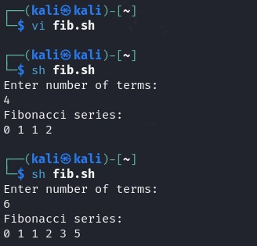

**RESULT**: Hence, Fibonacci series using shell script is executed successfully.

**CSE-CYBER SECURITY**